|  |  |
| --- | --- |
|  | Student Name _______________________    **Eastern Goldfields College**  Mathematics Applications U3&4 2019  Test 4 1– Calculator Free Section |
| **Working Time: 20 minutes** | **Total Marks: 21 marks** |

**Question 1 [3 marks: ½, ½, ½, ½, ½, ½]**

Which of the following situations involve time series data? *(Circle your answer)*

1. Comparing the average price of petrol each day by recording the average price and the day of the week for three consecutive weeks.

*Yes | No*

1. Recording data on the size of the ocean’s tides at 6 hour intervals by recording the level of the tide and the time of day for 5 consecutive days.

*Yes | No*

1. Comparing the fastest running time for each student in the class by recording their fastest time each day for 3 consecutive days.

*Yes | No*

1. 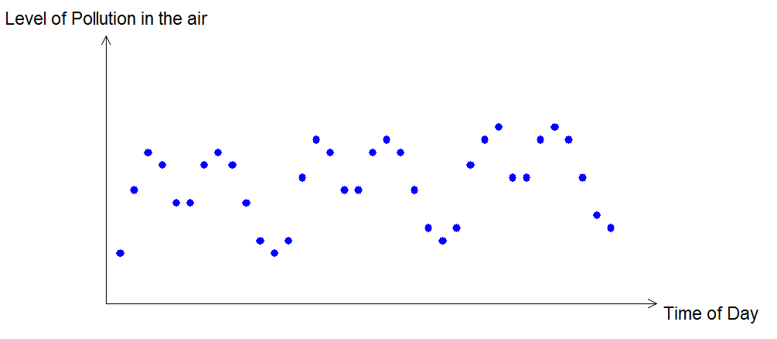

*Yes | No*

1. f)

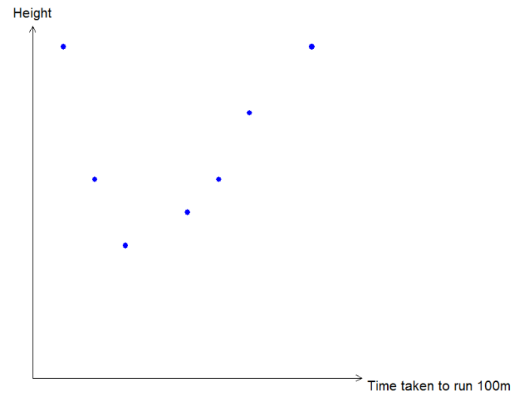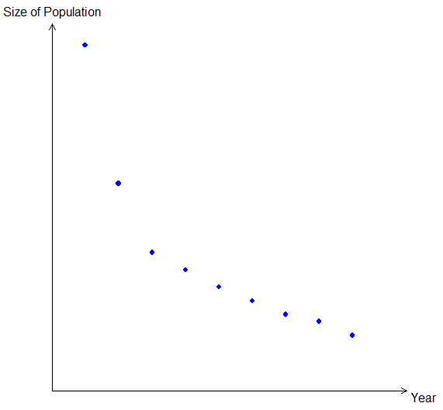

*Yes | No*

*Yes | No*

**Question 2 [7 marks: 2, 3, 2]**

The table below shows the number of members, $N$, of a swimming club who turned up for training over the first three weeks of winter. The club trained on Monday, Tuesday, Wednesday and Thursday each week.

|  |  |  |  |  |  |  |  |  |  |  |  |  |
| --- | --- | --- | --- | --- | --- | --- | --- | --- | --- | --- | --- | --- |
|  | Week 1 | | | | Week 2 | | | | Week 3 | | | |
| Day | M | T | W | T | M | T | W | T | M | T | W | T |
| Time, $t$ | 1 | 2 | 3 | 4 | 5 | 6 | 7 | 8 | 9 | 10 | 11 | 12 |
| Number, $N$ | 35 | 33 | 19 | 21 | 32 | 29 | 4 | 21 | 30 | 25 | 19 | 20 |

(a) Construct a time series plot of this data on the axes below.

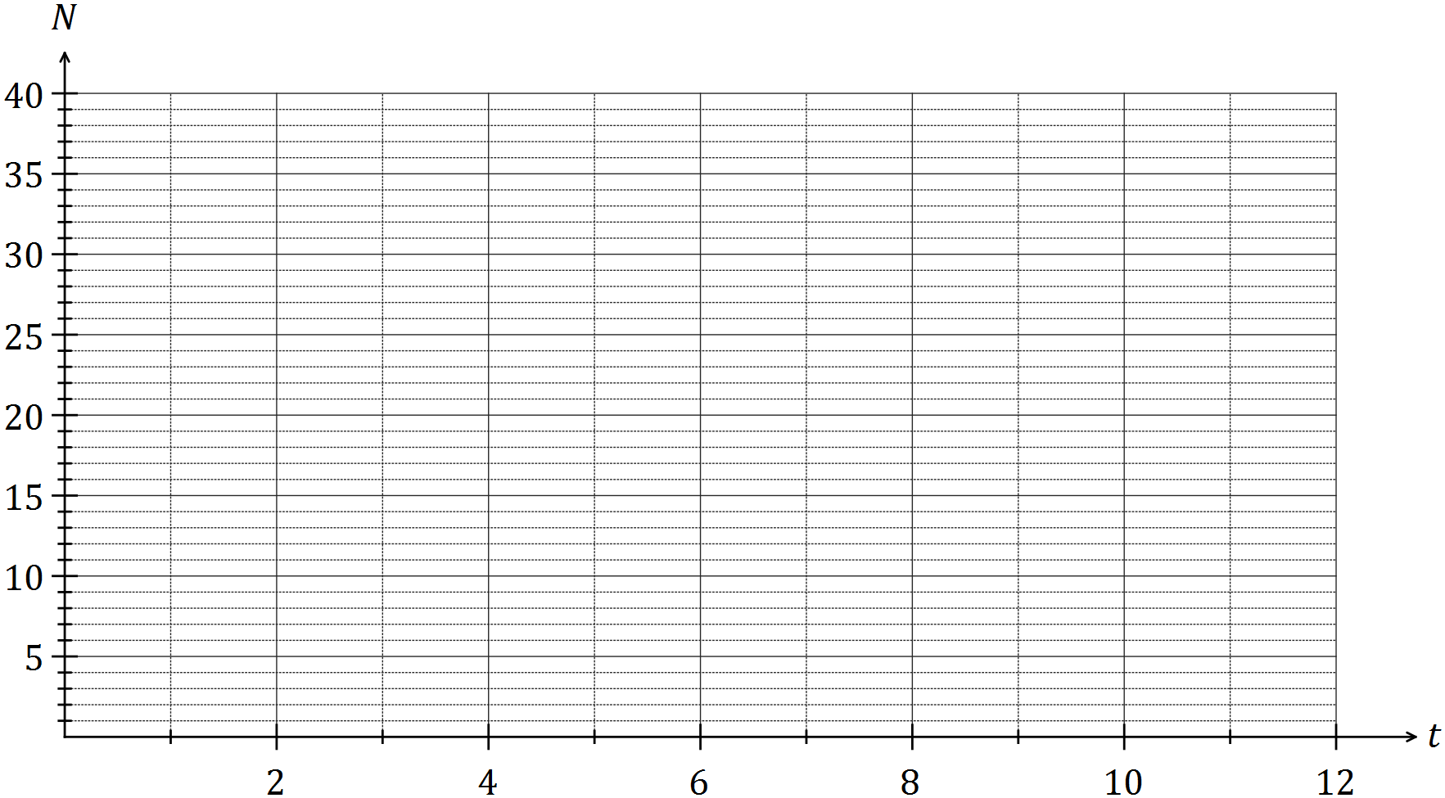

(b) Comment on features of the time series plot, including trend and seasonality.

(c) The trend line for the data is $N=30-0.9t$. Comment on the usefulness of this line as a short and long term trend model.

**Question 3 [4 marks: 1, 1, 2]**

|  |  |
| --- | --- |
| **Month-Year** | **Total number of employed persons in Australia 000’s** |
| Jan-2013 | 11301.0 |
| Feb-2013 | 11420.1 |
| Mar-2013 | 11431.5 |
| Apr-2013 | 11475.4 |
| May-2013 | 11485.4 |
| Jun-2013 | 11485.8 |
| Jul-2013 | 11473.8 |
| Aug-2013 | 11355.6 |
| Sep-2013 | 11533.0 |
| Oct-2013 | 11476.5 |
| Nov-2013 | 11439.8 |
| Dec-2013 | 11531.2 |
| Jan-2014 | 11316.8 |
| Feb-2014 | 11457.5 |
| Mar-2014 | 11528.4 |
| Apr-2014 | 11548.0 |
| May-2014 | 11547.6 |
| Jun-2014 | 11548.6 |
| Jul-2014 | 11535.6 |
| Aug-2014 | 11566.6 |
| Sep-2014 | 11535.8 |
| Oct-2014 | 11542.4 |
| Nov-2014 | 11572.7 |
| Dec-2014 | 11703.6 |
| Jan-2015 | 11454.5 |
| Feb-2015 | 11710.2 |
| Mar-2015 | 11684.6 |
| Apr-2015 | 11694.3 |
| May-2015 | 11764.2 |
| Jun-2015 | 11735.1 |
| Jul-2015 | 11743.8 |
| Aug-2015 | 11686.3 |
| Sep-2015 | 11756.9 |
| Oct-2015 | 11849.5 |
| Nov-2015 | 11919.1 |
| Dec-2015 | 12007.5 |

The following data has been provided by the Australian Bureau of statistics and shows the total number of employed persons in Australia in the 1000s. The data was collected monthly and is shown in the table right.

1. What is a way in which this data may have been collected?
2. List a reason why collecting this data might be useful?

Below is a graph of the data collected.

1. Describe the features of the time series plot.

Question 4 [7 marks: 2, 2, 1, 2]

The table below shows all but one of the seasonal indices for the daily sales figures for a recently opened pop-up store that is closed on Mondays and Tuesdays.

|  |  |  |  |  |  |
| --- | --- | --- | --- | --- | --- |
| Day | Wednesday | Thursday | Friday | Saturday | Sunday |
| Seasonal index | 0.65 | 0.70 |  | 1.35 | 1.50 |

(a) Determine the seasonal index for Friday. (2 marks)

(b) One weekend, the pop-up store had sales worth $3 000 on Saturday and $3 000 on Sunday. If these sales figures were deseasonalised, which day would have the highest sales? Justify your answer. (2 marks)

(c) The equation of the trend line for deseasonalised sales, $S$ in dollars, after the store had been open for $t$ days was $S=195t+1640$.

(i) Interpret the value of the slope of this line in this context. (1 mark)

(ii) Write down an expression that would forecast the actual sales of the pop-up shop on the Wednesday when $t=31$. **Do not** evaluate your expression. (2 marks)

|  |  |
| --- | --- |
|  | Student Name _______________________    **Eastern Goldfields College**  Mathematics Applications U3&4 2019  Test 4 1– Calculator Assumed Section |
| **Working Time: 35 minutes** | **Total Marks: 34 marks** |

**Question 5 [6 marks: 5, 1]**

A company’s quarterly earnings ($000’s) for the past 3 years are listed in the table below.

1. Use the information in the partially completed table below to calculate the values of   
   A, B, C, D and E.

|  |  |  |  |  |
| --- | --- | --- | --- | --- |
| Year/Quarter | Company Earnings  ($ 000’s) | 4 Point Centred Moving Average | Average for the Year | Company Earnings as a percentage of Yearly average |
| 2012 – 1 | 38 |  | **B** |  |
| 2012 – 2 | 45 |  |  |
| 2012 – 3 | 20 | **A** |  |
| 2012 – 4 | 78 | 44.25 |  |
| 2013 – 1 | 35 | 43.75 | 43 | **C** |
| 2013 – 2 | 43 |  | 100% |
| 2013 – 3 | 18 |  | 41.86% |
| 2013 – 4 | **D** | 41.625 | 176.74% |
| 2014 – 1 | **E** |  | 40.25 |  |
| 2014 – 2 | 40 | 40.375 |  |
| 2014 – 3 |  | 40.125 |  |
| 2014 – 4 |  | 39.75 |  |
| 2015 – 1 | 30 | 39.625 | 38.5 |  |
| 2015 – 2 | 38 | 39.125 |  |
| 2015 – 3 | 16 |  |  |
| 2015 – 4 |  |  |  |

1. Why does it make sense to consider a 4 point moving averages for this data?

**Question 6 [6 marks: 1, 2, 3]**

The following table shows the seasonal indices for the weekly sales figures for a particular company.

|  |  |  |  |  |  |  |  |
| --- | --- | --- | --- | --- | --- | --- | --- |
| **Day** | Monday | Tuesday | Wednesday | Thursday | Friday | Saturday | Sunday |
| **Seasonal Index** | 98% | 80% | 79% |  | 102% | 141% | 70% |

1. Calculate the seasonal index for Thursday.
2. The actual sales figure for Friday is $25 300. Calculate the deseasonalised sale figure for Friday.

The least squares regression line for predicting the deseasonalised sale figure for this week of sales is given by deseasonalised sales figure=20.2+0.89×day number, where day 1 is Monday, day 2 is Tuesday etc and sales are in thousands of dollars.

1. Calculate the actual sales figure for Sunday.

**B**

**A**

**C**

**Question 7 [22 marks – 2, 3, 2, 2, 4, 2, 2, 3, 2]**

A street market has recently opened. It is open 3 days a week. Attendance is recorded and tracked for the first three weeks of the market opening.

|  |  |  |  |
| --- | --- | --- | --- |
| **Week/Day** | **Attendance (000’s)** | **Weekly Mean** | **Attendance Percentage of Mean** |
| **Week 1 / 1** | 12 | $$8.\dot{3}$$ | 144% |
| **Week 1 / 2** | 8 | 96% |
| **Week 1 / 3** | 5 | 60% |
| **Week 2 / 1** | 9 | $$7.\dot{6}$$ | 117.39% |
| **Week 2 / 2** | 8 | 104.35% |
| **Week 2 / 3** | 6 | 78.26% |
| **Week 3 / 1** | 9 | $$8.\dot{3}$$ | 108% |
| **Week 3 / 2** | 9 | 108% |
| **Week 3 / 3** | 7 | 84% |

1. The seasonal index for Day 2’s is 102.78%. Explain what this figure means.

1. Calculate the seasonal index for Day 1 and for Day 3.
2. Complete the following table of the deseasonalised data for attendance at the street market. Rounding your answer to **2 decimal places**.

|  |  |
| --- | --- |
| **Week/Day** | **Deasonalised Attendance (000’s)** |
| 1 /1 |  |
| 1 / 2 | 7.78 |
| 1 / 3 | 6.75 |
| 2 / 1 | 7.31 |
| 2 / 2 |  |
| 2/ 3 | 8.10 |
| 3 / 1 | 7.31 |
| 3 / 2 | 8.76 |
| 3 / 3 |  |

1. 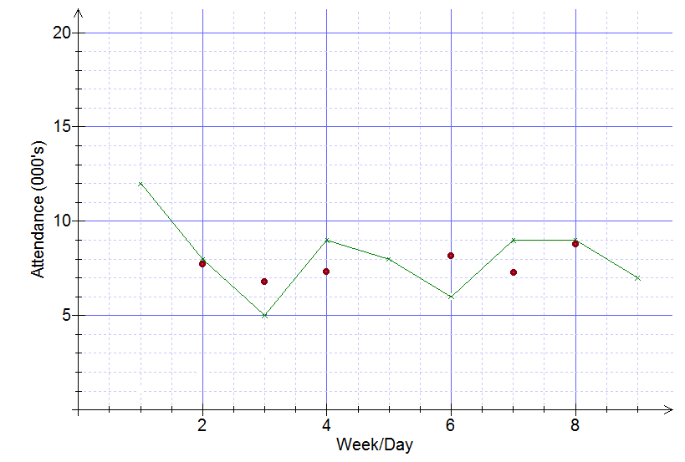 Complete the following graph for the deseasonalised data.
2. State the rule for the least squares regression line for the deseasonalised data and add this line to the scatterplot of the deseasonalised attendance.
3. Compare the deseasonalised data to that of the actual data and comment on the effect of deasonalising the data.
4. Calculate the deseasonalised attendance figure for each day in the fourth week.
5. Using deseasonalised attendance prediction, estimate the actual attendance for the fourth week.
6. Explain how reliable your prediction is for the estimated actual attendance for the fourth week.

**END OF TEST**